MOU on Collaborative Partnership with Insaafdaar

Nov 26, 2024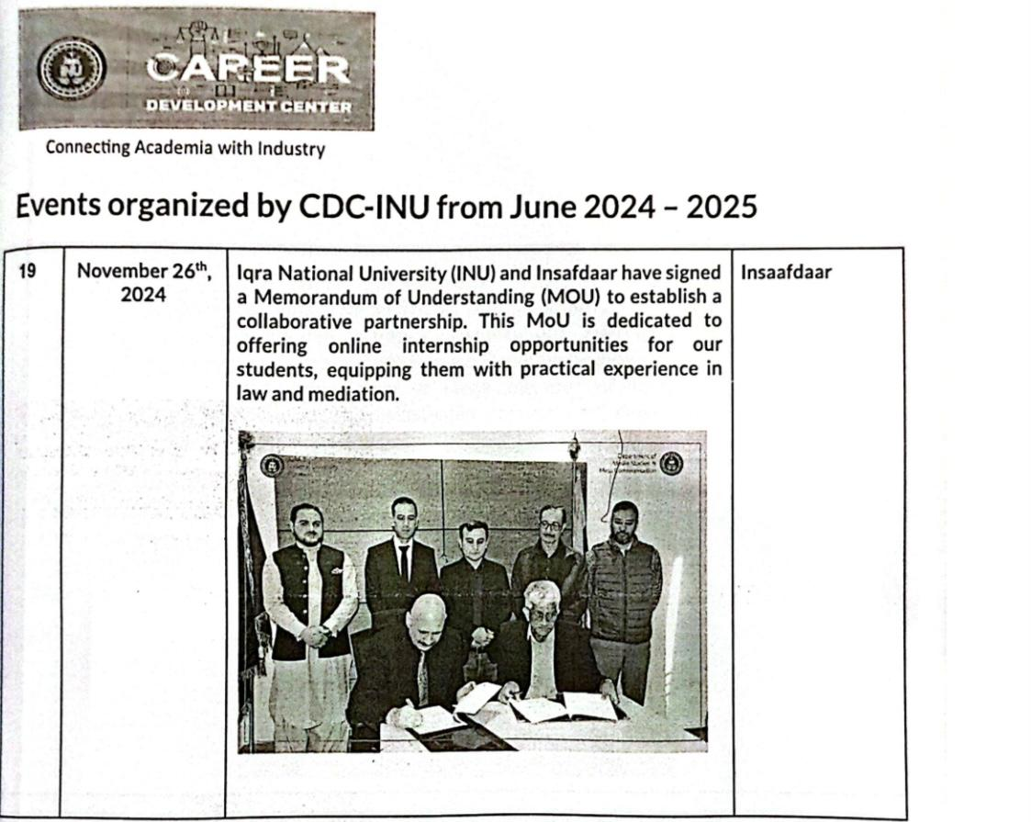

MOU on Collaborative Partnership with Civic Innovator of Pakistan

Nov 18, 2024

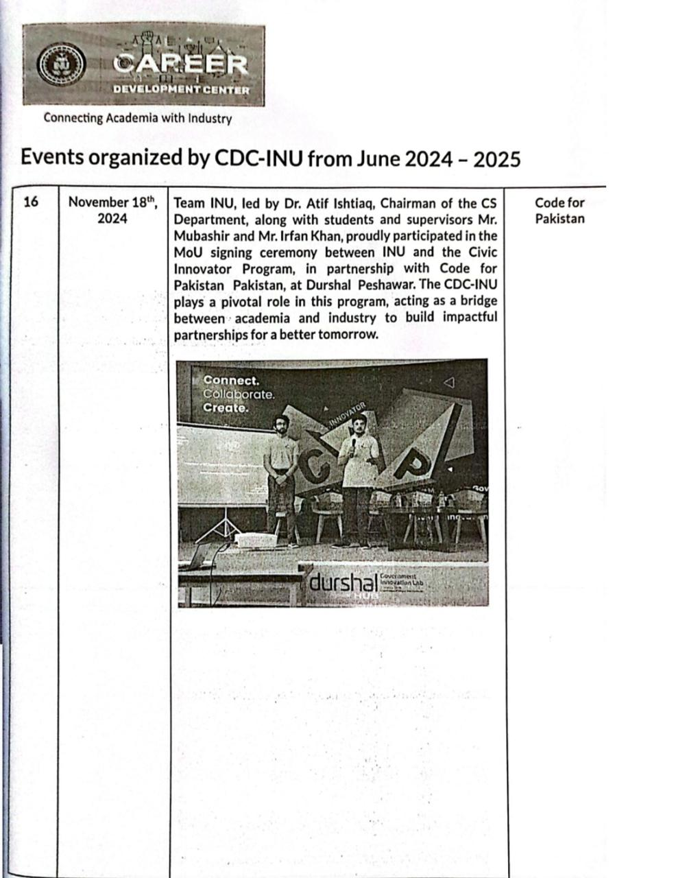

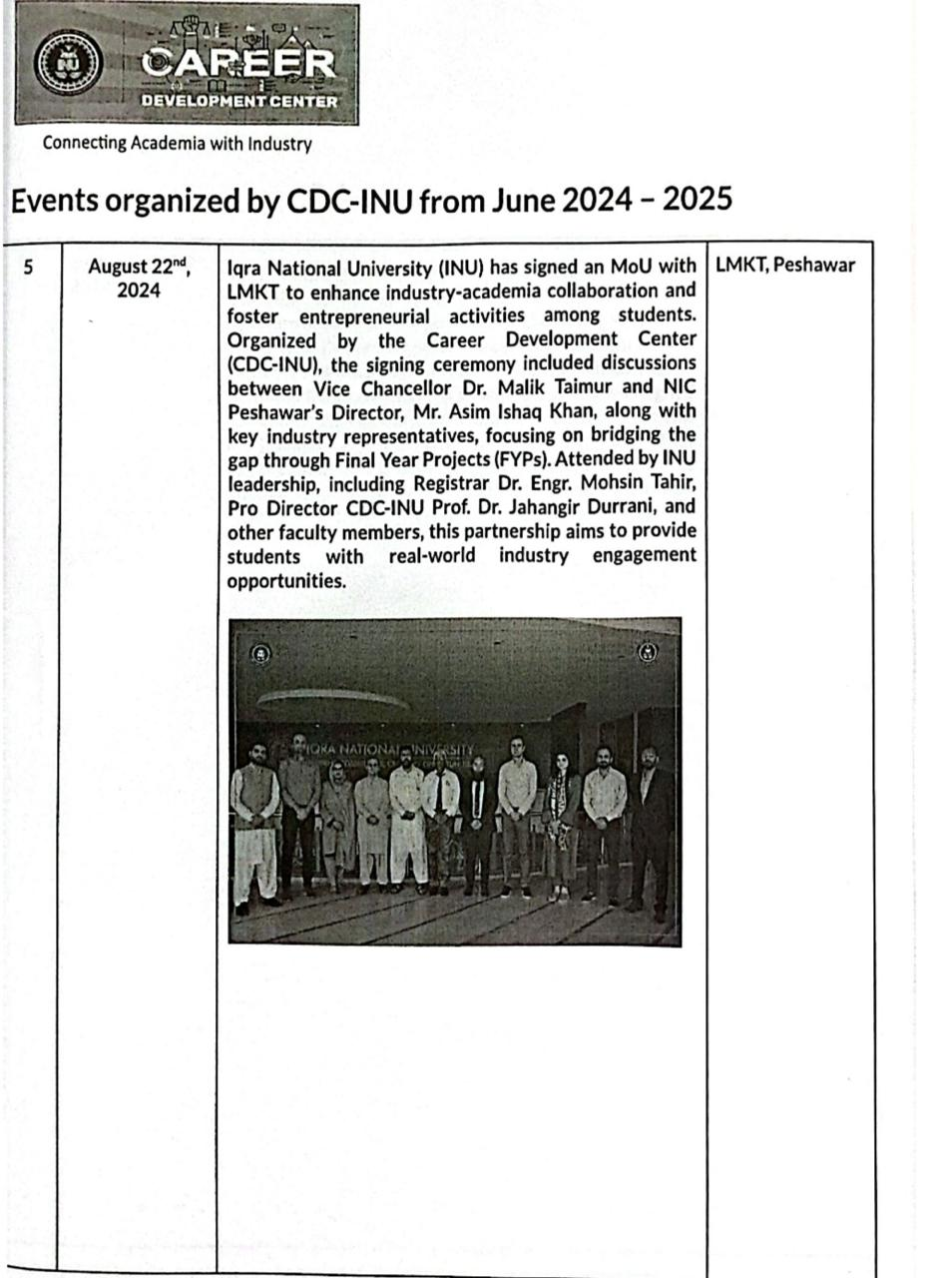
MOU Signing with LMKT to Enhance Industory-Academia Collaboration Aug 22, 2024

