Workshop on Entrepreneurship by National Incubation Center Peshawar

October 1, 2024
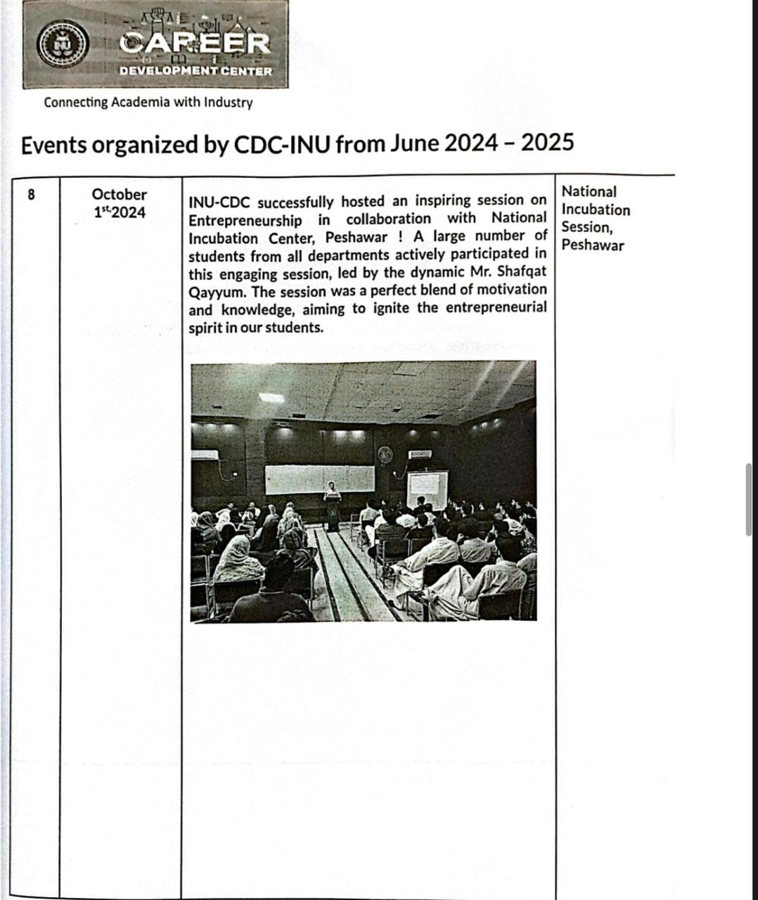

Workshop on Professional Growth and Work Ethics

October24, 2024

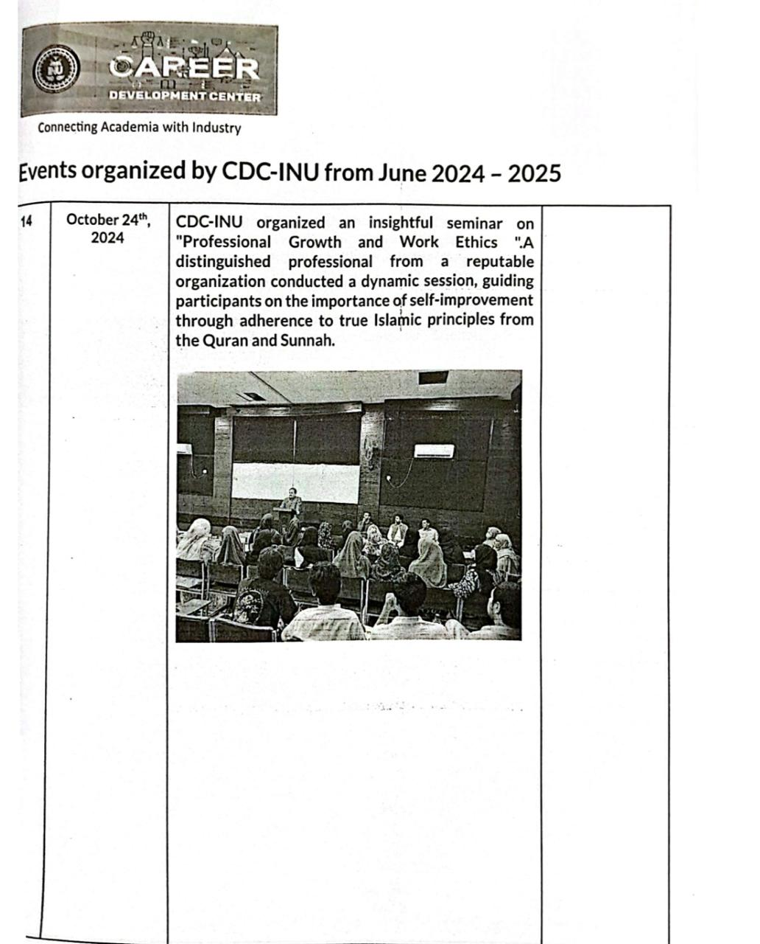

Business Development Workshop by Relief International

June 15, 2023
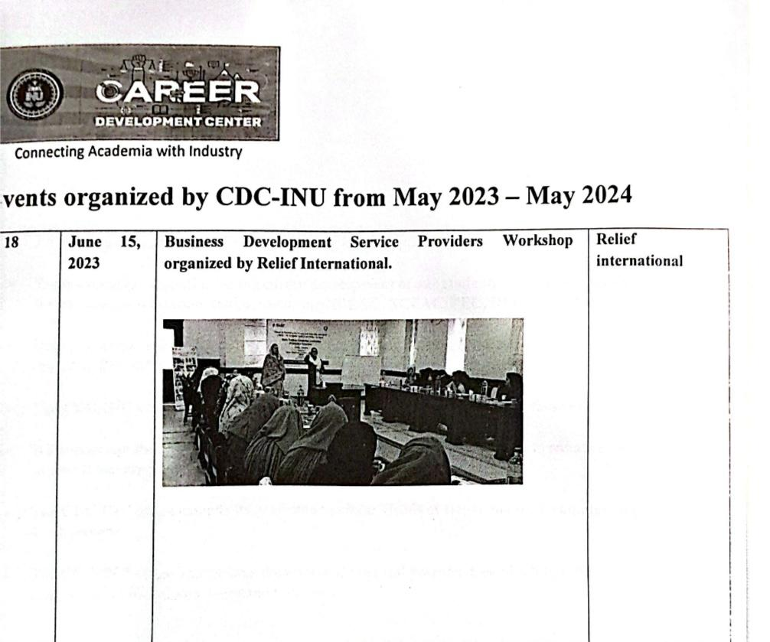

Workshop on Career Opportunities in Pakistan Airforce

May 22, 2024
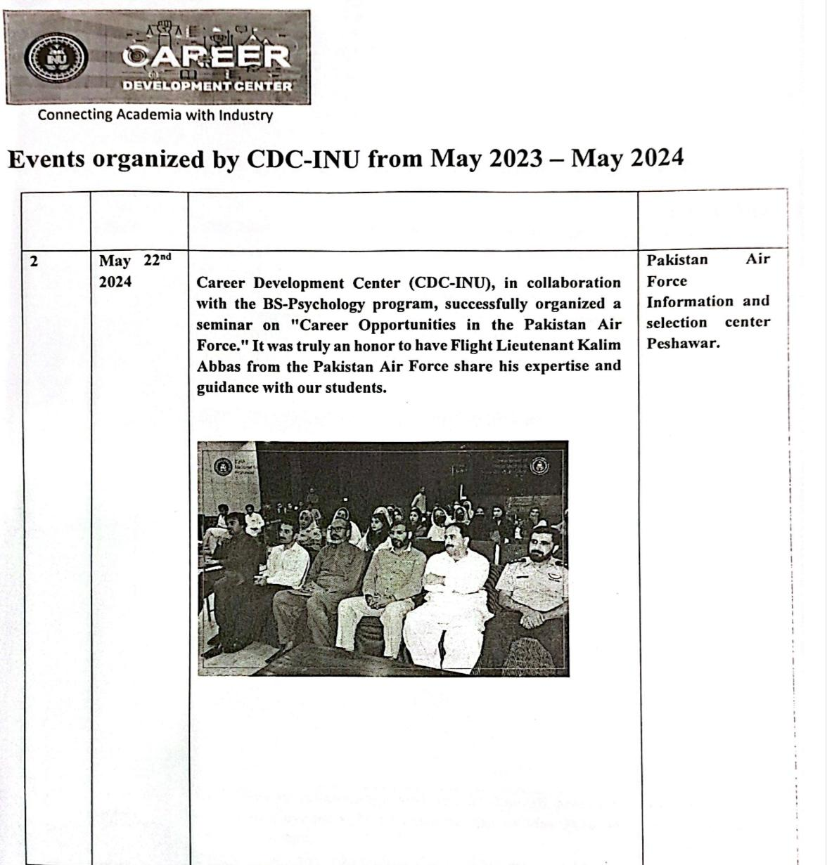

Workshop on Tax Management by Regional Tax Office Peshawar

Oct 25, 2023
