Volunteering in Plantation Drive Peshawar Development Authority August 13, 2025
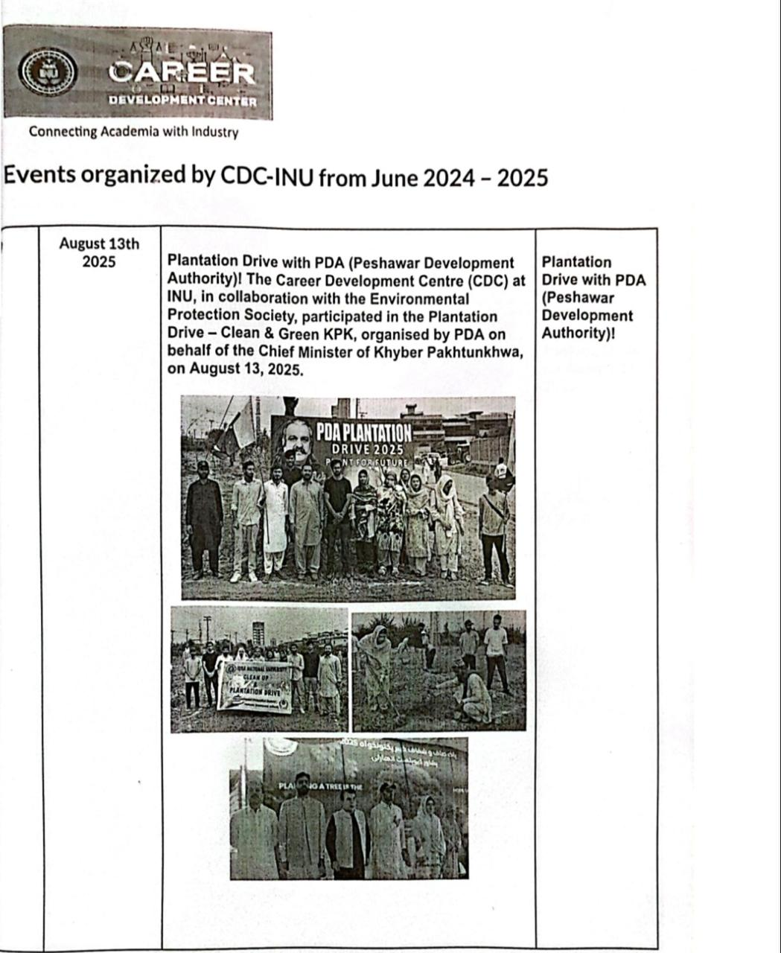

Volunteering in Clean and Green Peshawar, by Peshawar Development Authority Oct 19, 2023
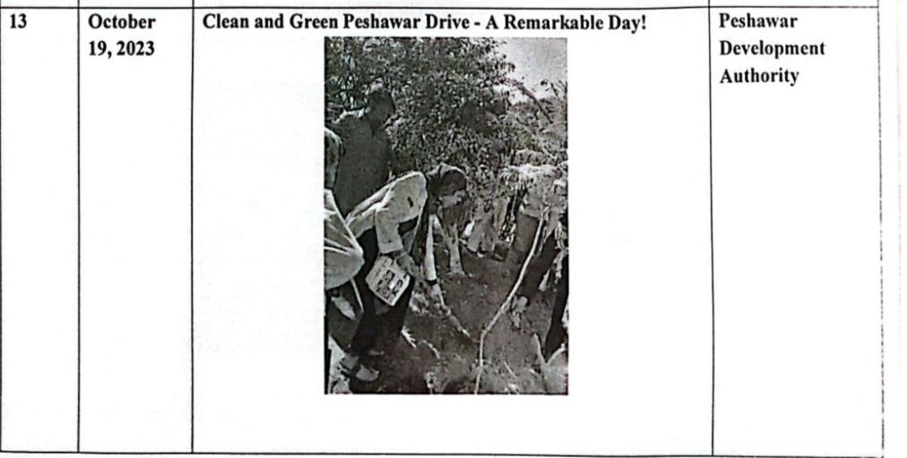

Volunteering in Clean and Green Peshawar, by Peshawar Development Authority Oct 19, 2023

