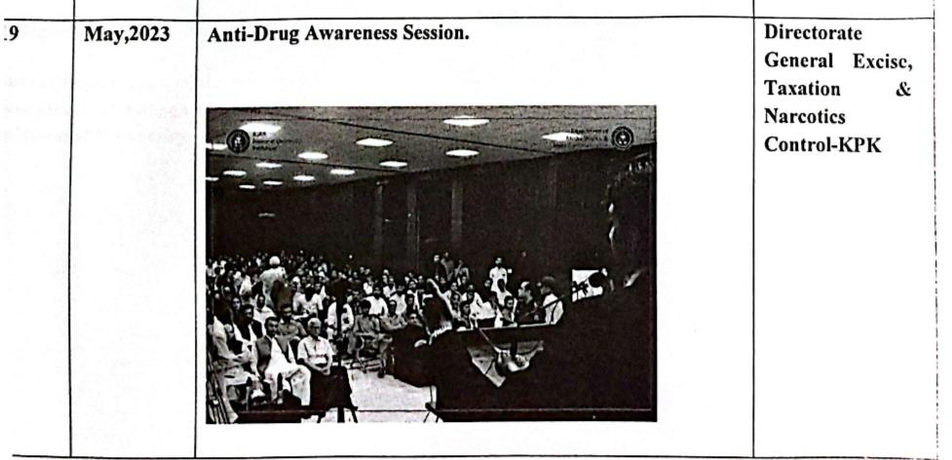
Anti-Drug Awareness Session by Directorate of Narcotics Control May 2023.

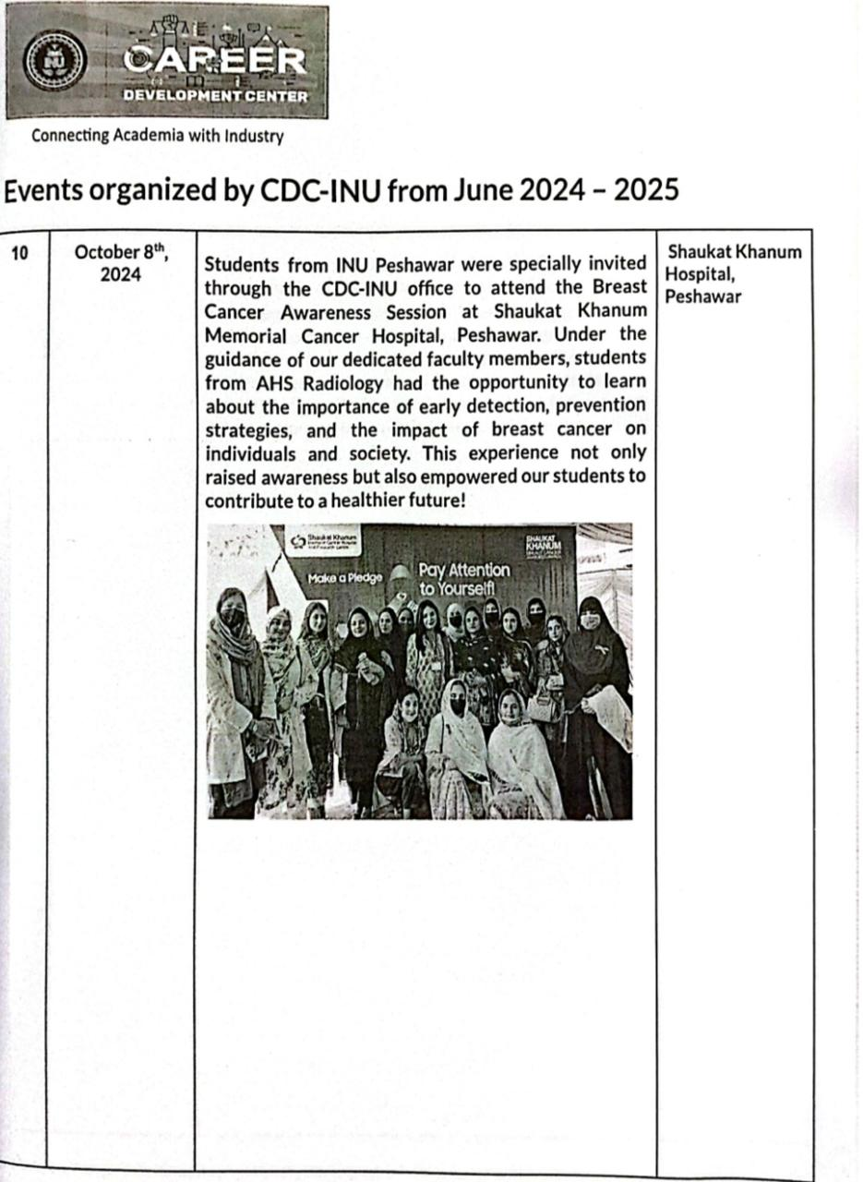
Breast Cancer Awareness Session by Shaukat Khanam, Cancer Hospital Peshawar. Oct 8, 2025

